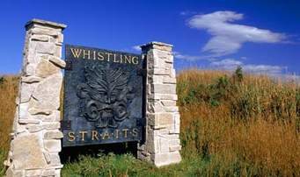

2 Person Scramble @ Whistling Straits - The Straits Course

December 17th – December 23rd

$100/Team

